Experiment 4: Histogram Equalization
Aim: To implement histogram equalization using OpenCV and compare the equalized image with the original image.
Procedure:
- Read the input image.
- Convert it into grayscale.
- Apply histogram equalization using cv2.equalizeHist().
- Display the original grayscale image and equalized image.
- Compare the contrast of both images.
Program:
import cv2
import matplotlib.pyplot as plt
img = cv2.imread(r"D:\Amrita\Pictures\Screenshots\image.png")
gray = cv2.cvtColor(img, cv2.COLOR_BGR2GRAY)
equalized = cv2.equalizeHist(gray)
plt.subplot(1, 2, 1)
plt.imshow(gray, cmap="gray")
plt.title("Original Image")
plt.subplot(1, 2, 2)
plt.imshow(equalized, cmap="gray")
plt.title("Equalized Image")
plt.show()

Input:
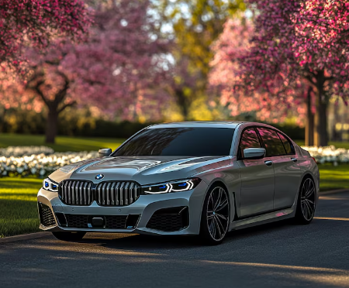
Output:
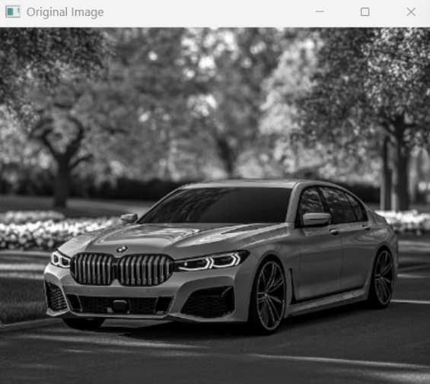
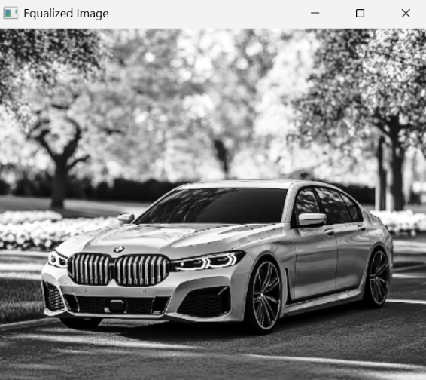
Result:
Histogram equalization was successfully performed, improving the contrast of the grayscale image where appropriate.

